

**Assignment**

Microprocessor and Assembly Language Lab

**CSEL-3106**

|  |  |
| --- | --- |
| **Submitted by**  Md. Waliul Islam Rayhan  ID: B190305034 | **Submitted to**  Arnisha Akhter  Lecturer  Dept. of CSE, Jagannath University |

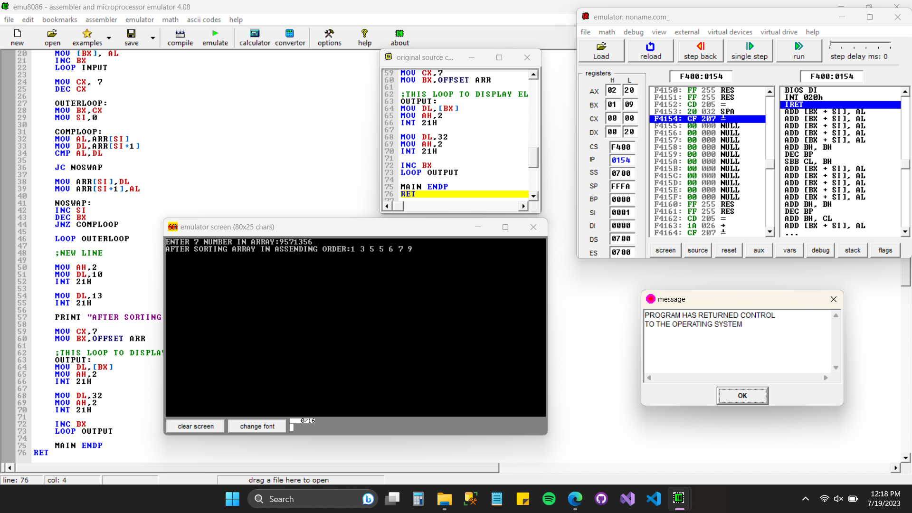

Screenshot: 01 — 1. Sort numbers in Ascending Order (1)

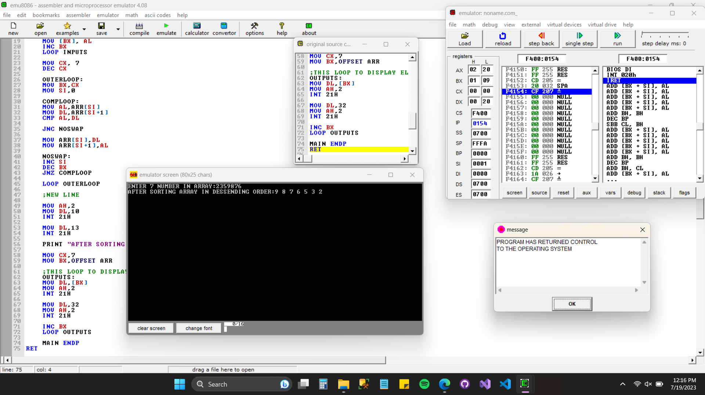

Screenshot: 02 — 1. Sort numbers in Descending Order (2)

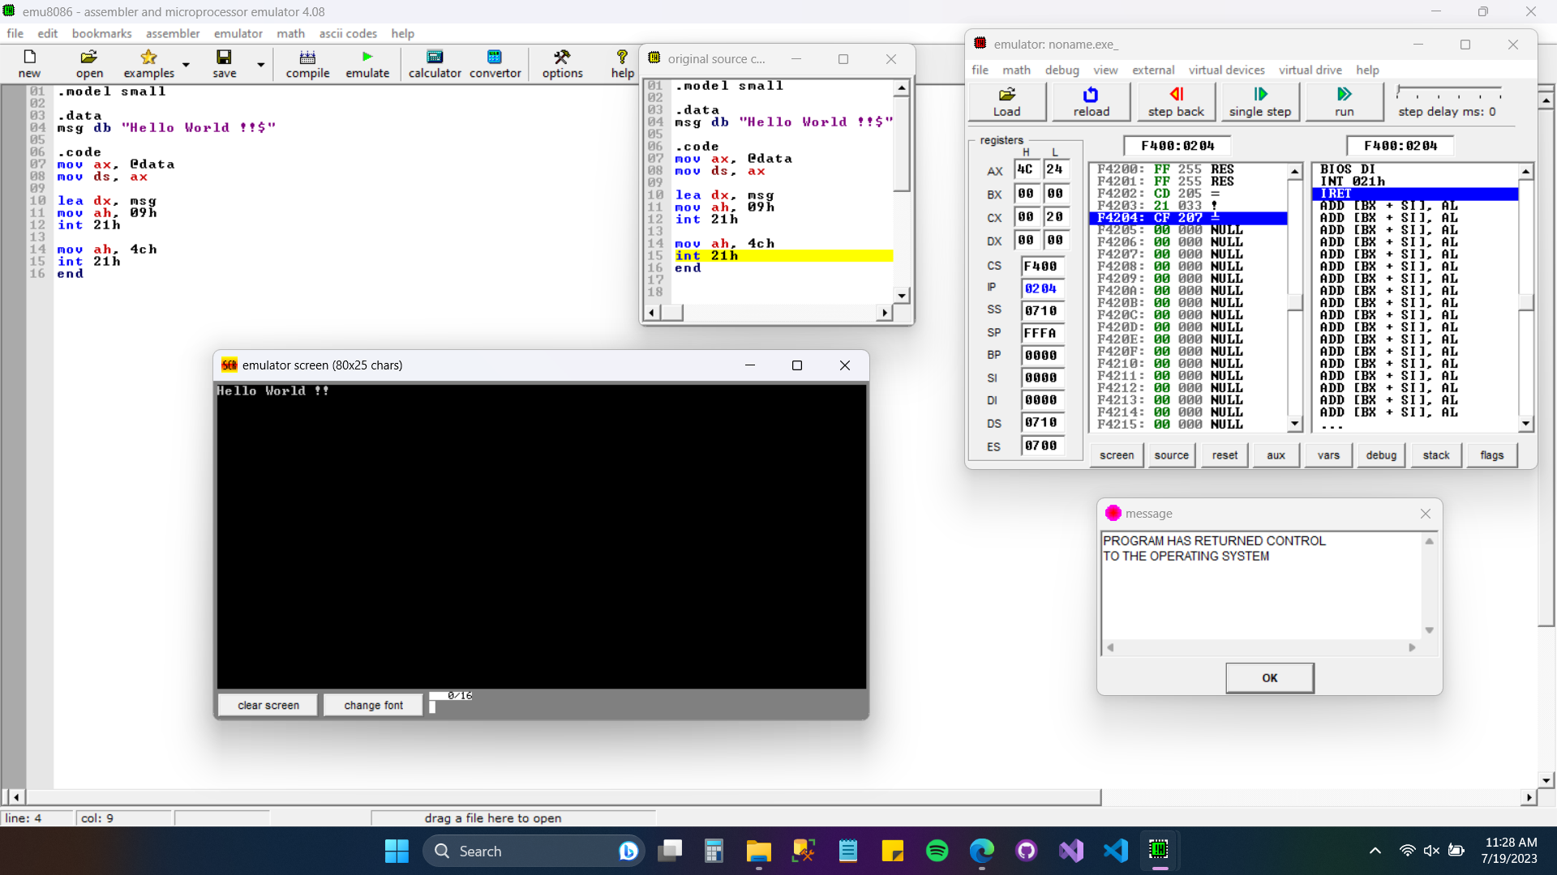

Screenshot: 03 — 4. Program to display a string.

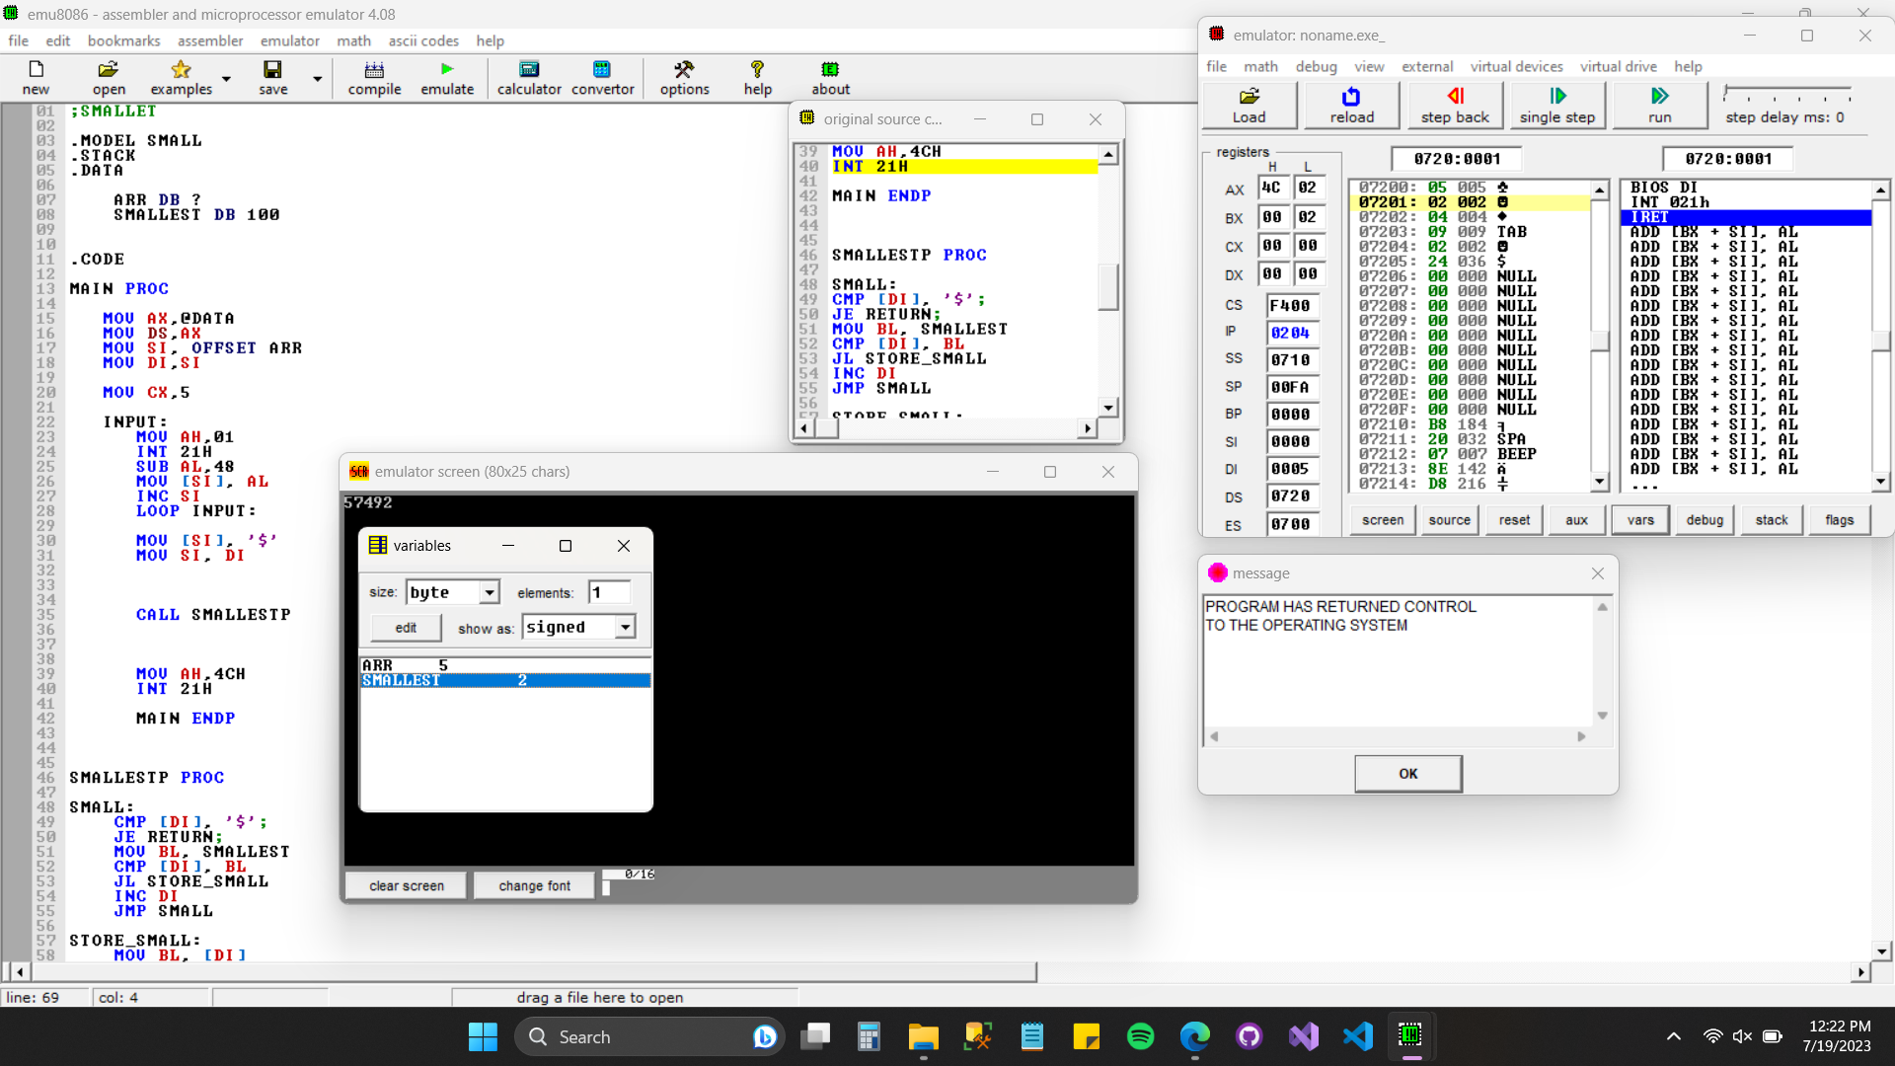

Screenshot: 04 — 5. Find the smallest number.

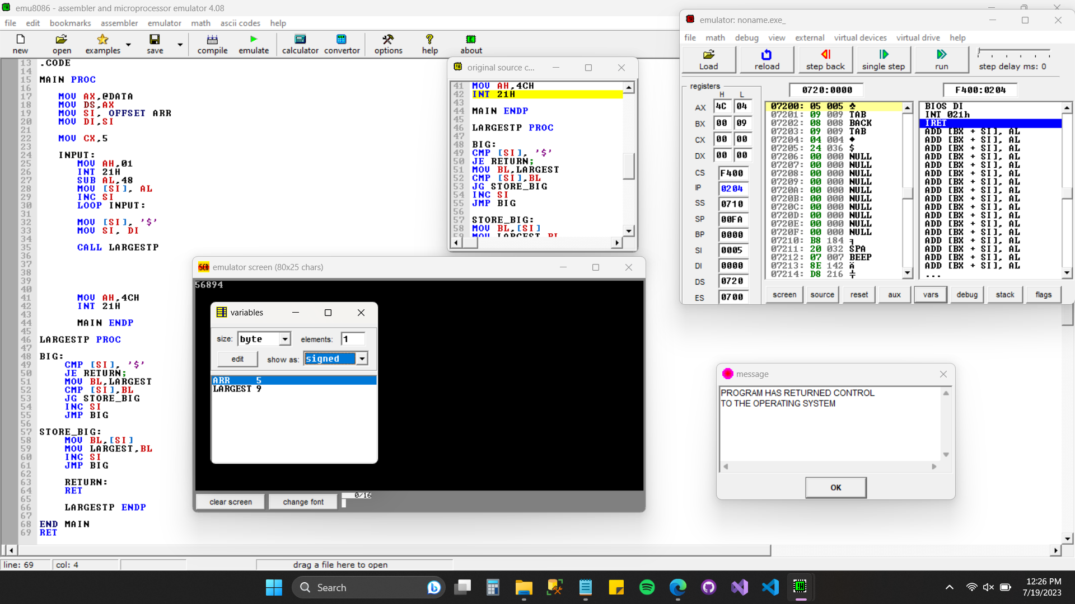

Screenshot: 05 — 6. Find the largest number.

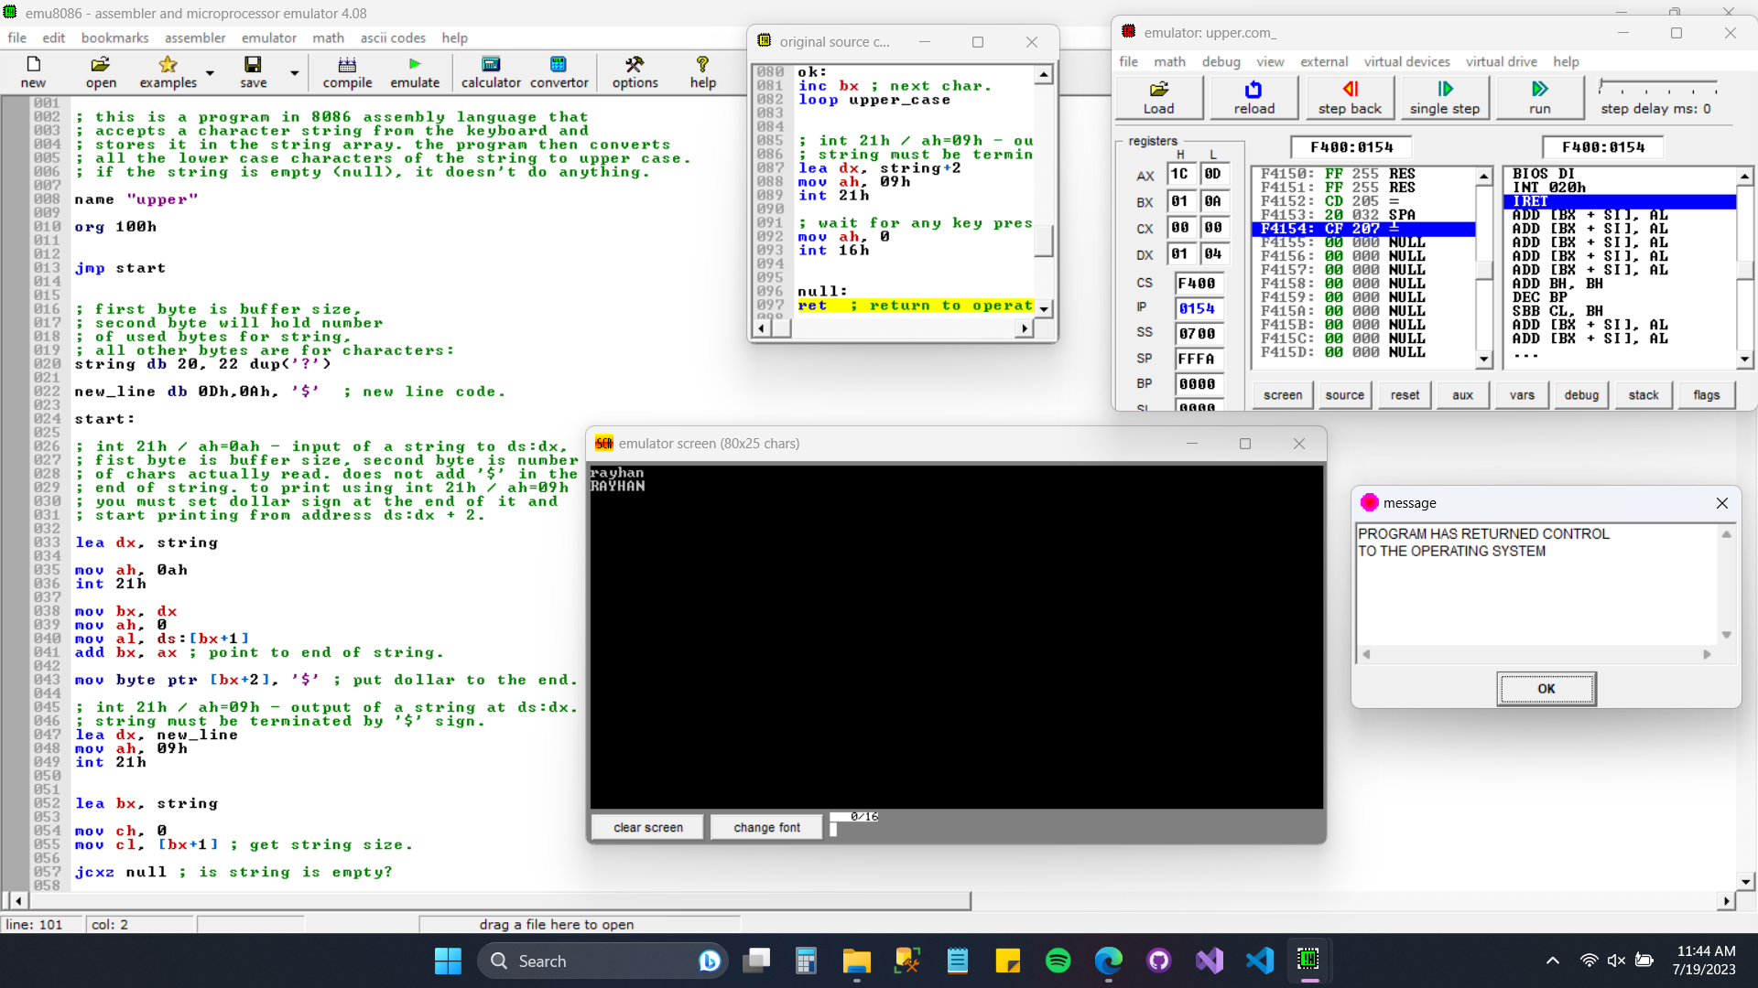

Screenshot: 06 — 7. Convert lowercase letter to uppercase.

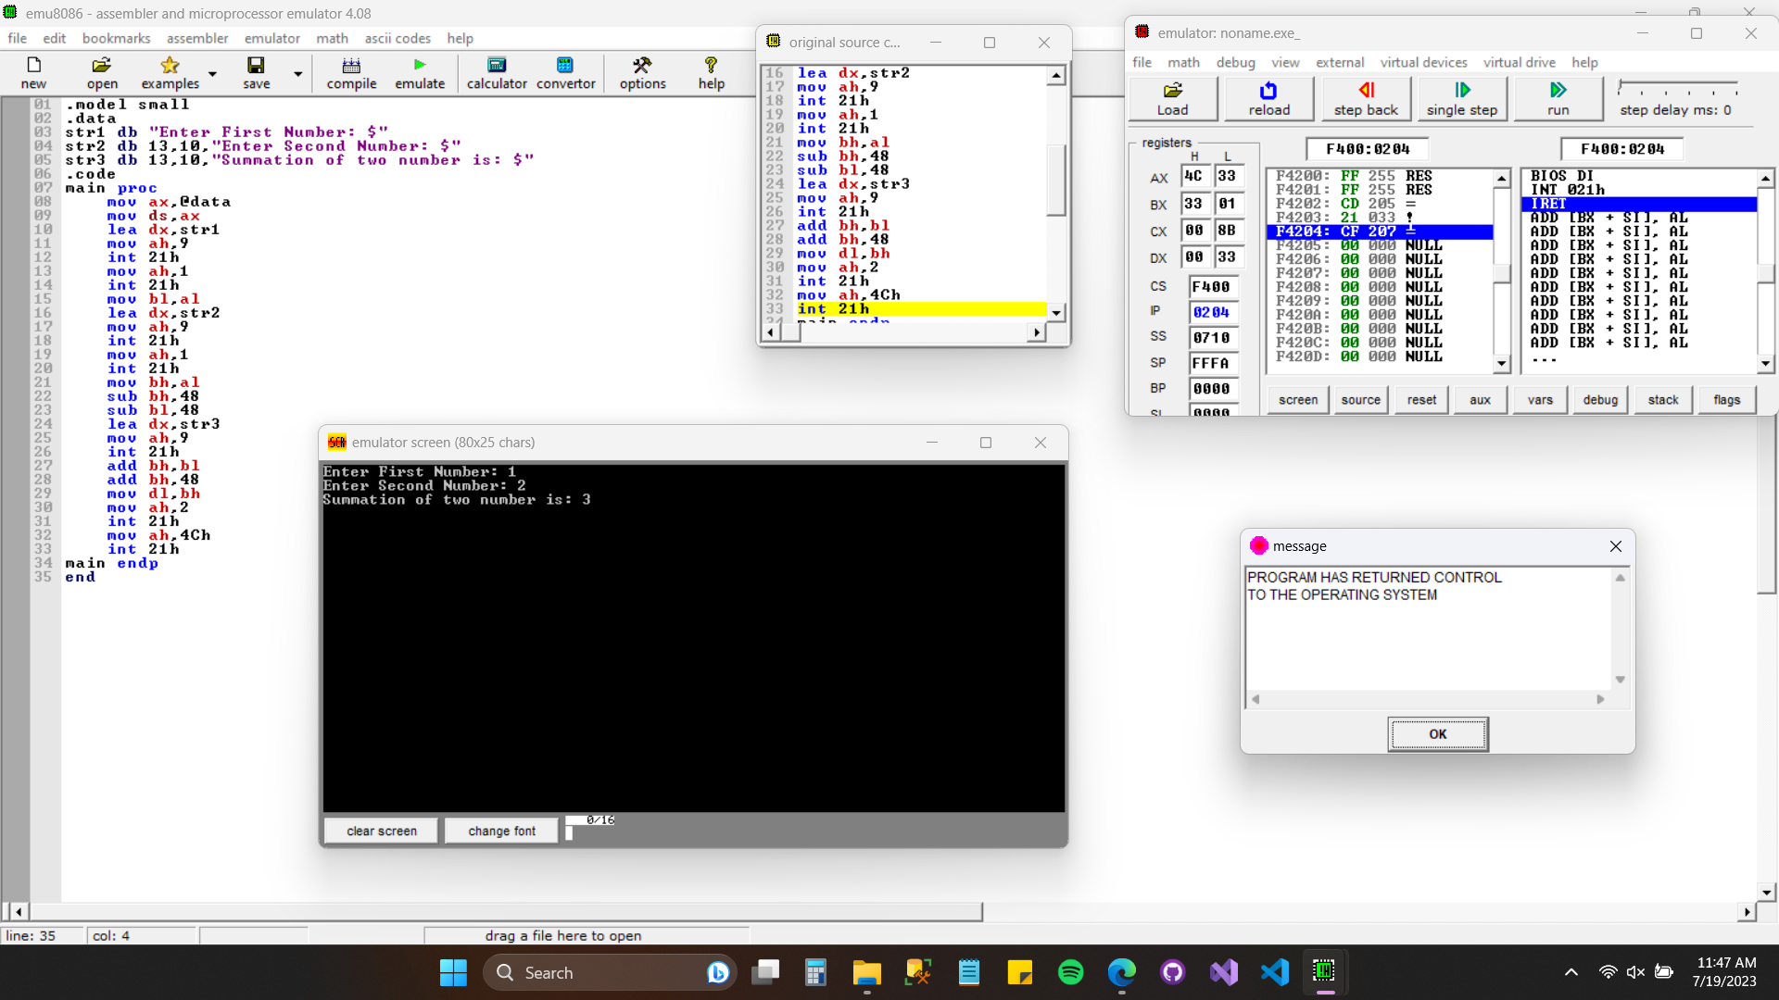

Screenshot: 07 — 9. Add 2 numbers.

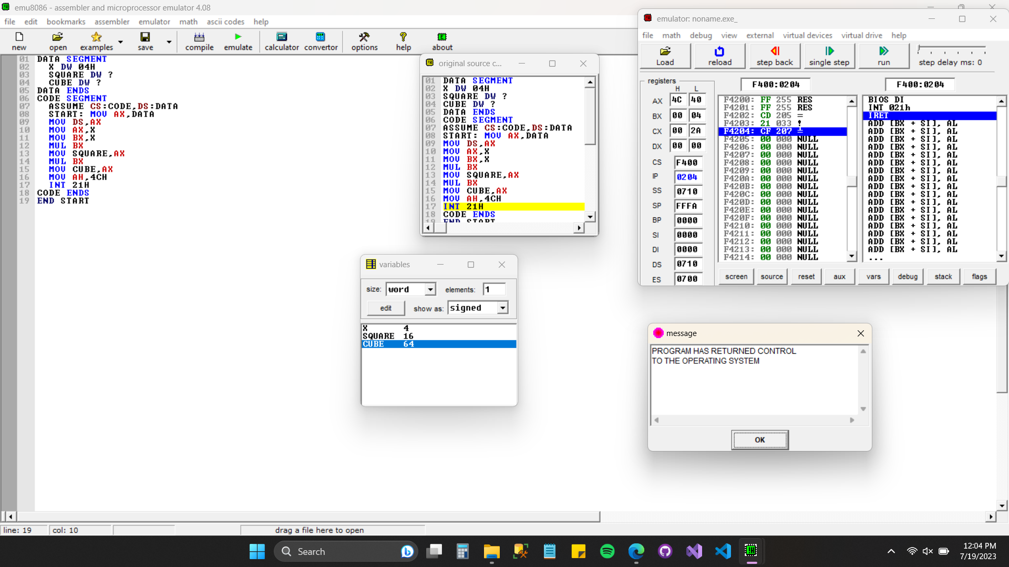

Screenshot: 08 — 13. Find square and cube of a number.

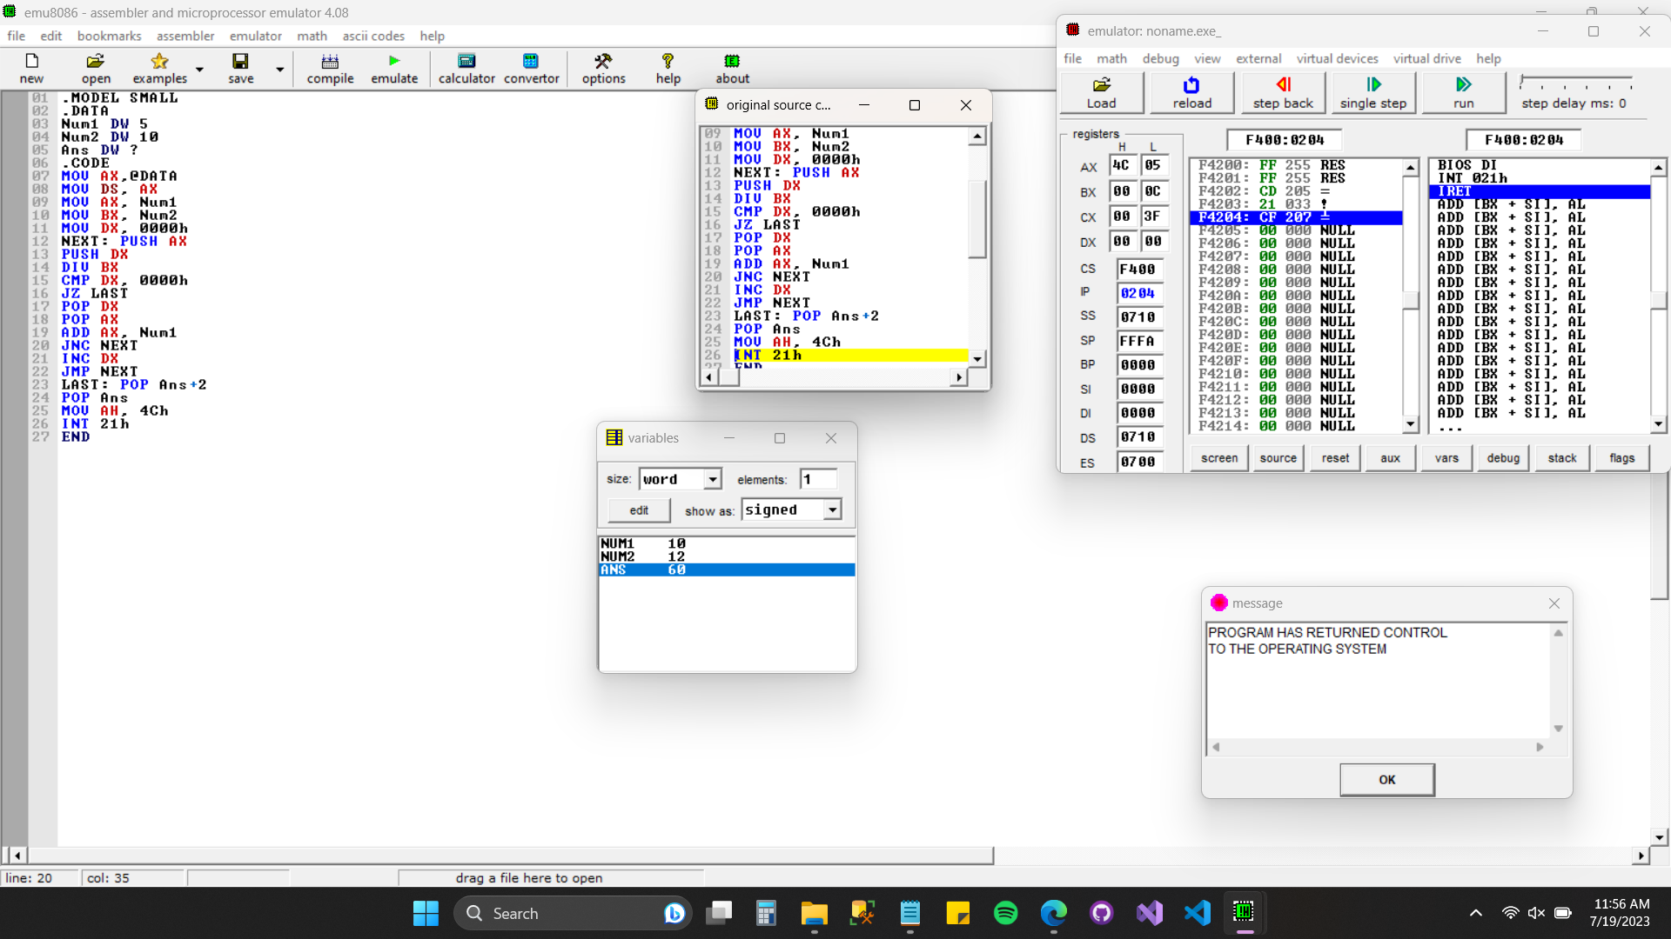

Screenshot: 09 — 14. Find the LCM of the given number.

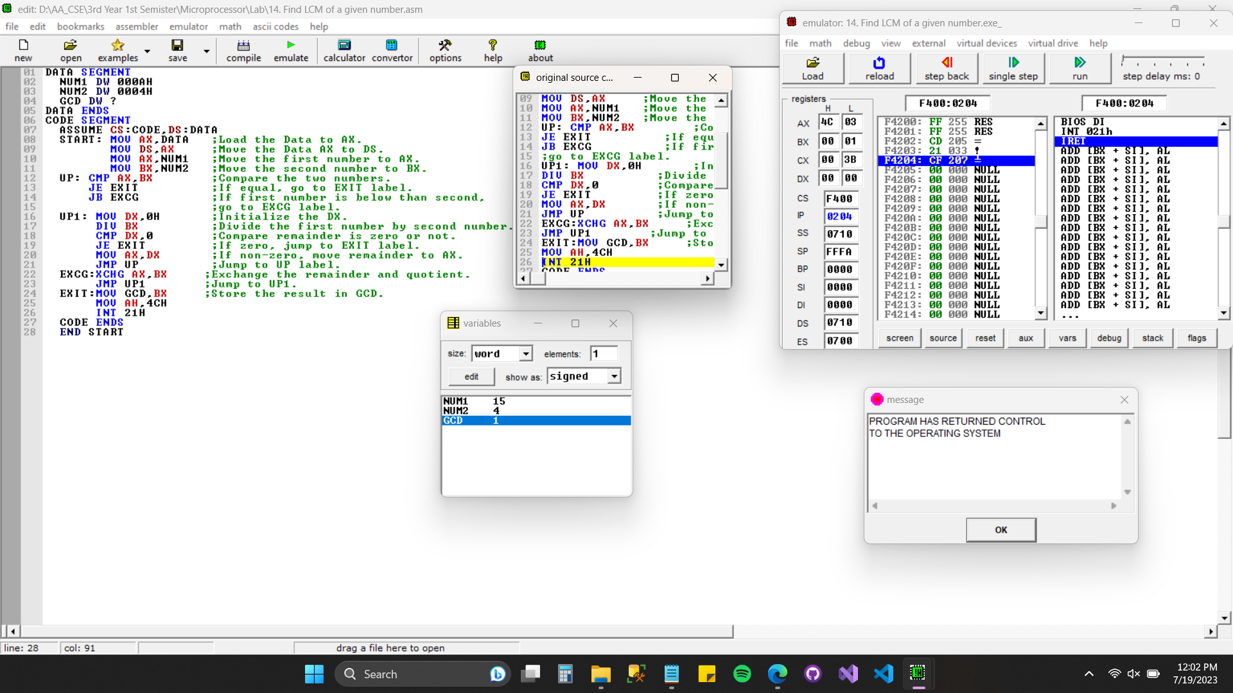

Screenshot: 10 — 16. Find GCD of two numbers.

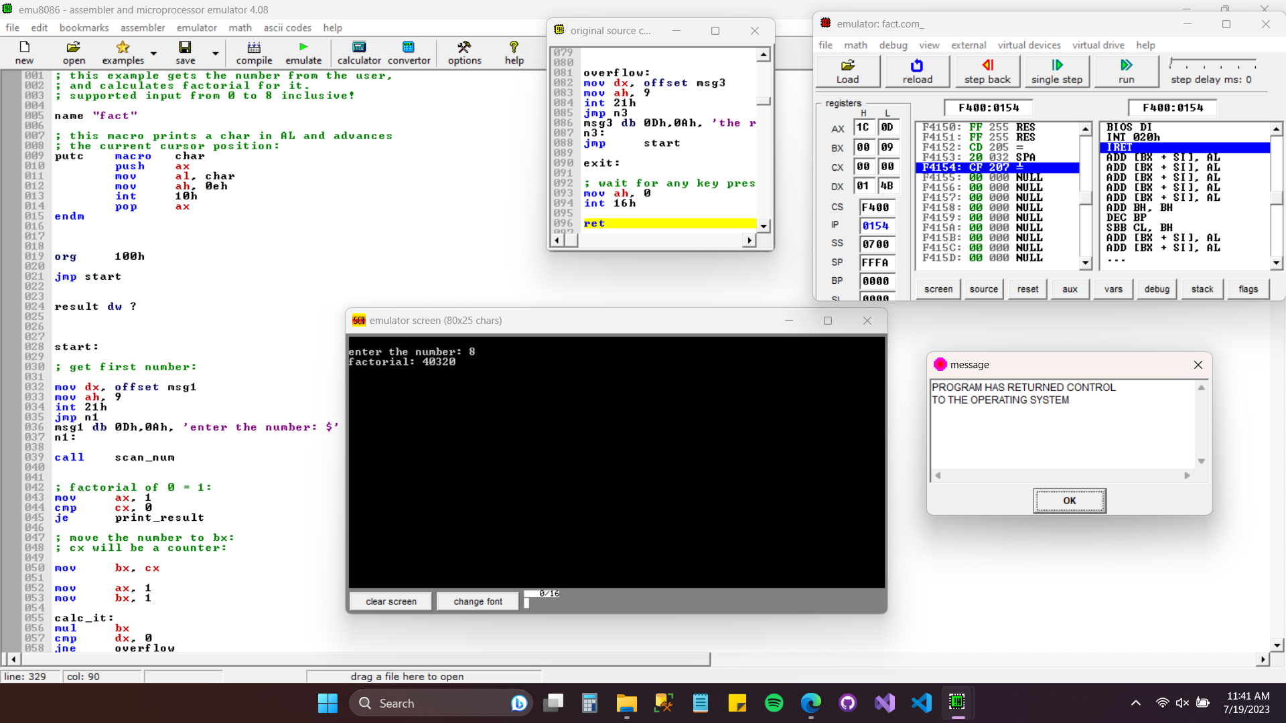

Screenshot: 11 — 17. Find the factorial of a given number.

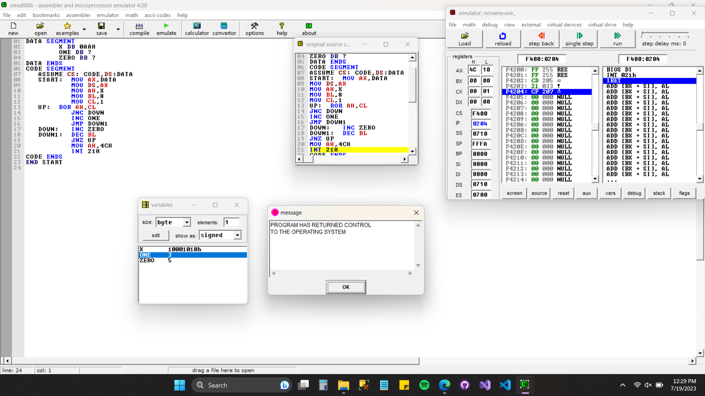

Screenshot: 12 — 22. Logical ones and zeroes in given data.

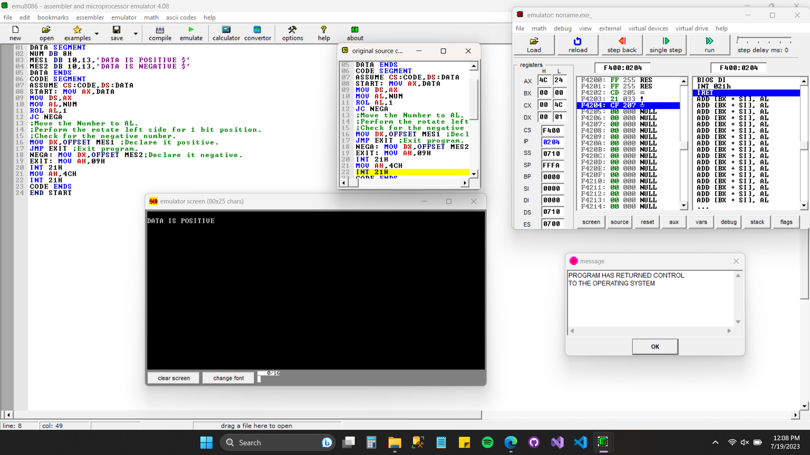

Screenshot: 13 — 23. Find the data is positive or negative.

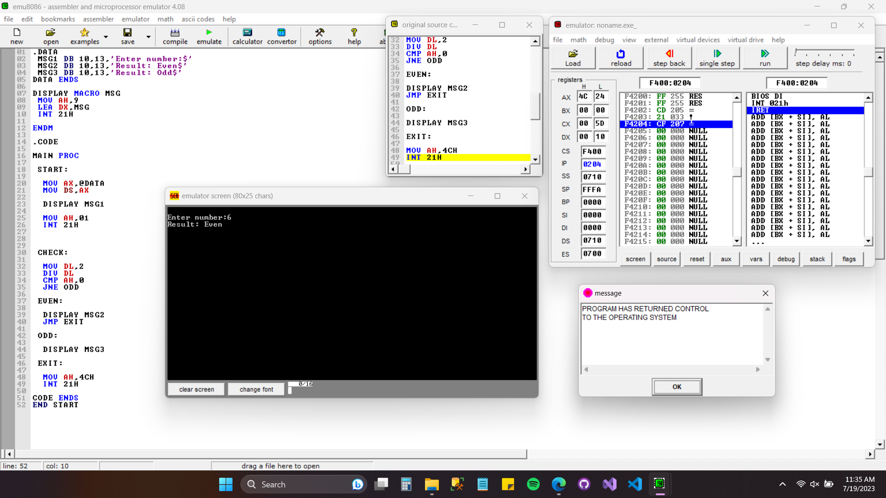

Screenshot: 14 — 24. Find the data is odd or even (even).

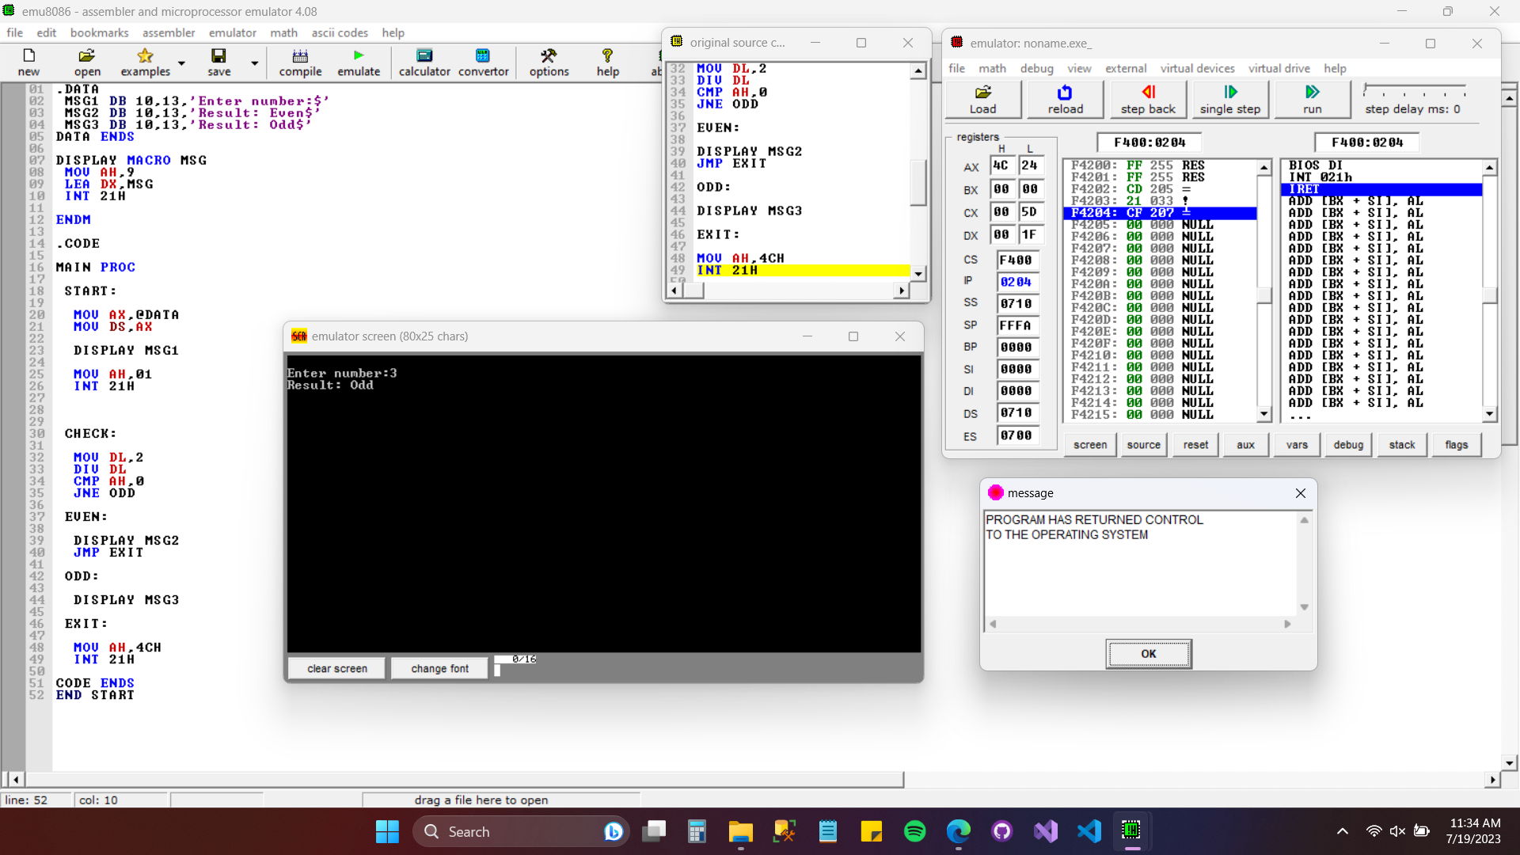

Screenshot: 15 — 24. Find the data is odd or even (odd).

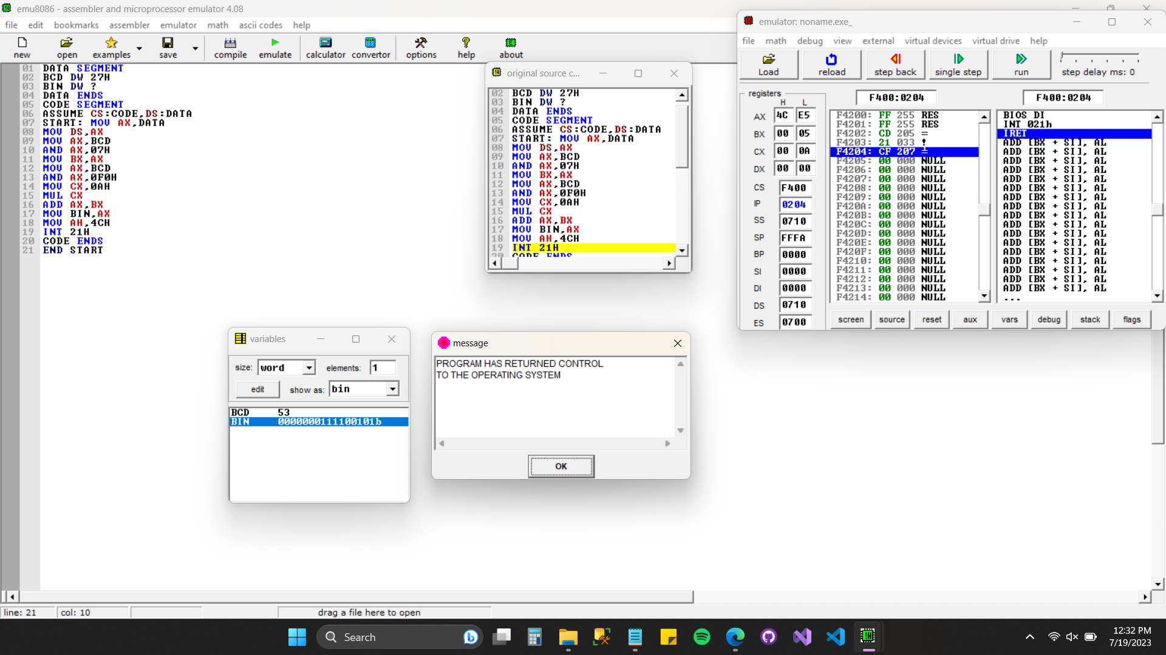

Screenshot: 16 — 27. BCD to Binary code conversion.

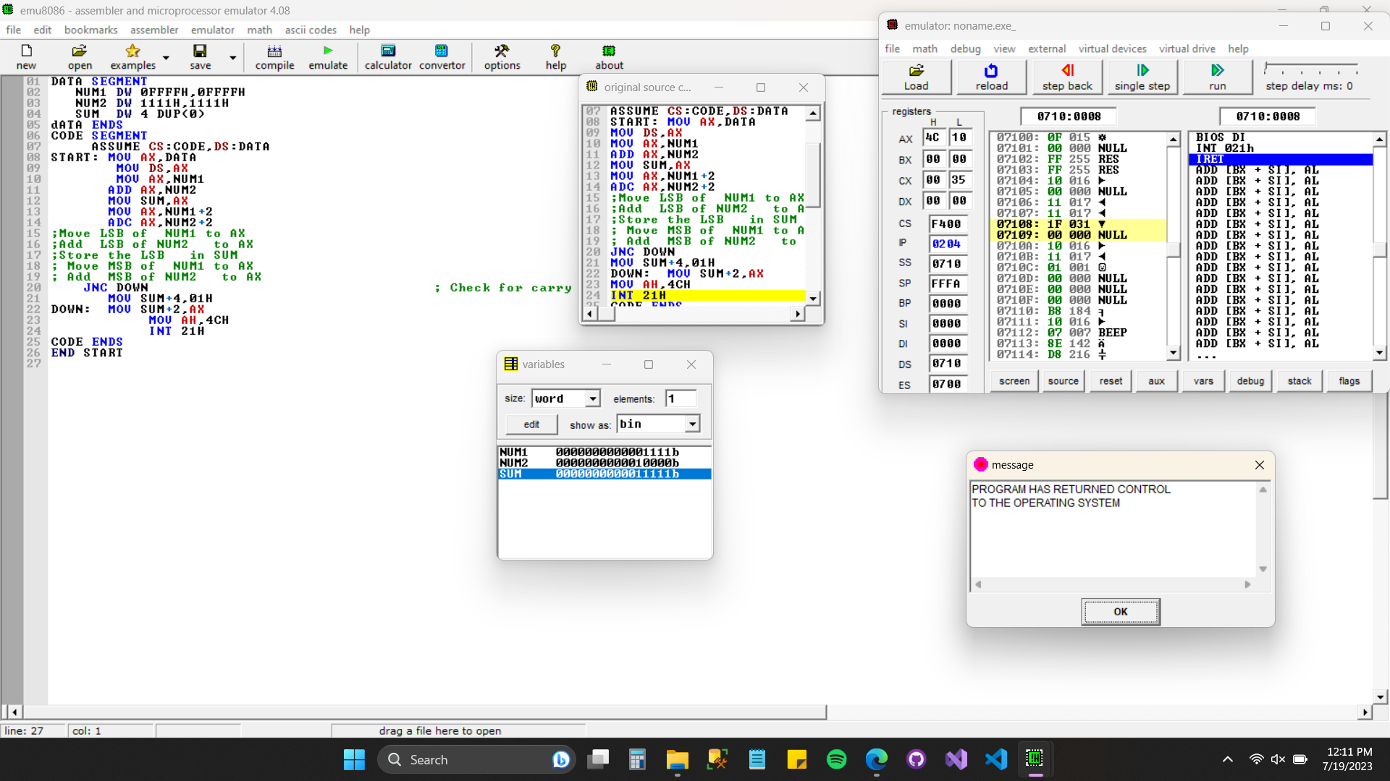

Screenshot: 17 — 29. 32-bit Addition.